RNN_LSTM_GRU_keras

test02LSTM_mnist手写字体十分类

下面为keras2.0 英文官网说明
keras.layers.LSTM(units, activation='tanh', recurrent_activation='hard_sigmoid', use_bias=True, kernel_initializer='glorot_uniform', recurrent_initializer='orthogonal', bias_initializer='zeros', unit_forget_bias=True, kernel_regularizer=None, recurrent_regularizer=None, bias_regularizer=None, activity_regularizer=None, kernel_constraint=None, recurrent_constraint=None, bias_constraint=None, dropout=0.0, recurrent_dropout=0.0, implementation=1, return_sequences=False, return_state=False, go_backwards=False, stateful=False, unroll=False)
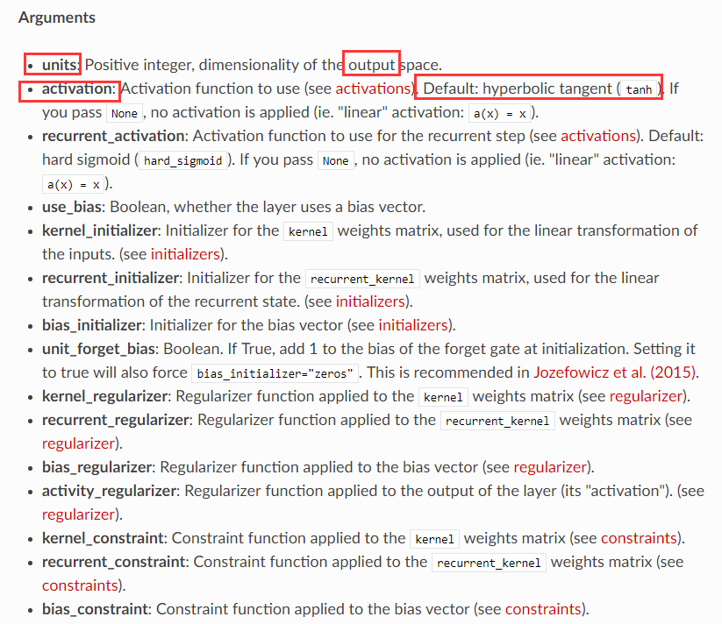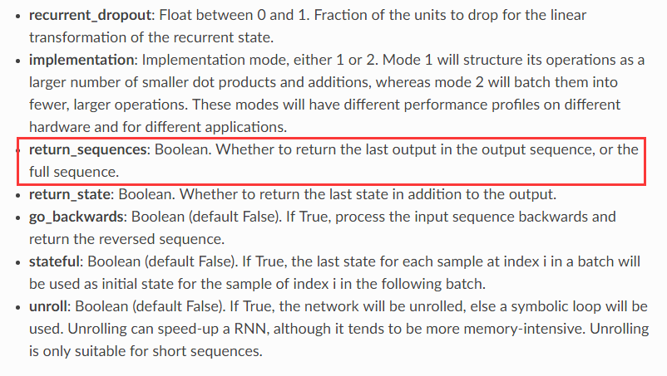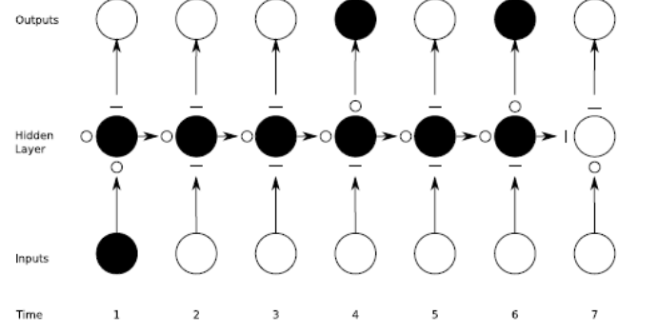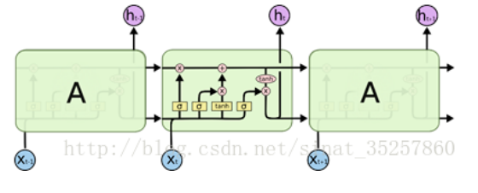
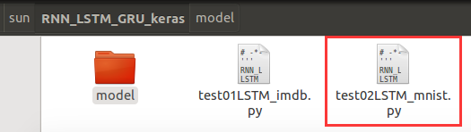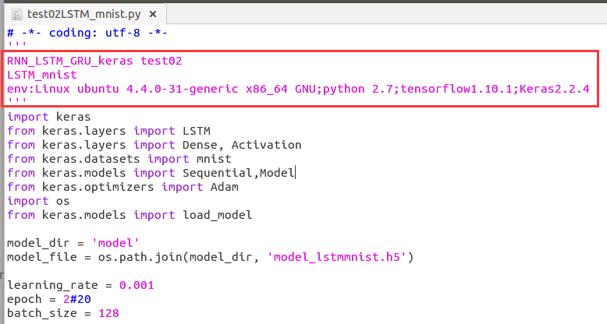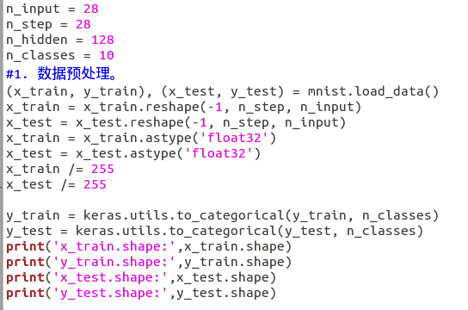
sun@ubuntu:~/sun/RNN_LSTM_GRU_keras$ python test02LSTM_mnist.py
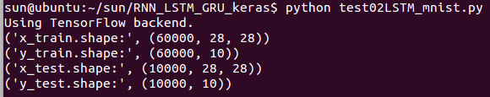
首先搭建网络并进行训练（注释掉红色段落）
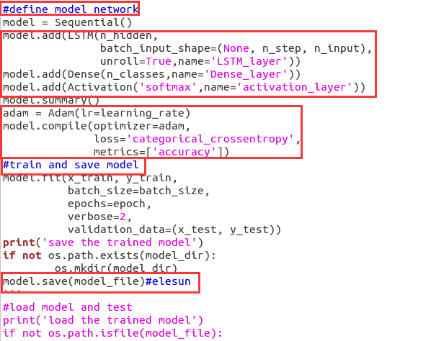
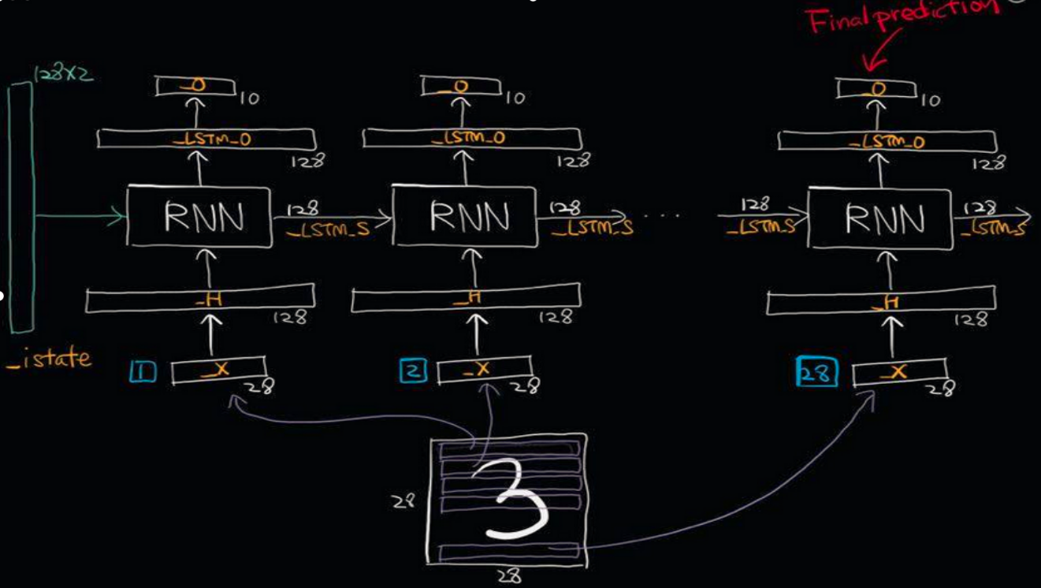
Train_data=60000*28*28,samples=60000
Epoch=50；Batch_size=128,train_steps= 60000/128=469
Units=n_hidden=output_dim=128;frames=timesteps=n_step=28;input_dim=n_input=28维向量（每个单词用28维向量表示）

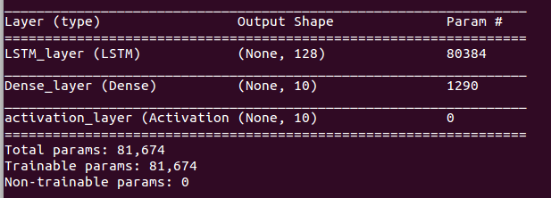
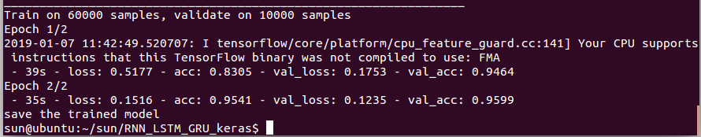
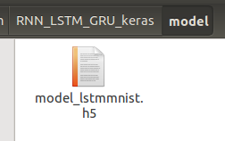
然后加载模型参数并测试结果（注释掉红色段落）
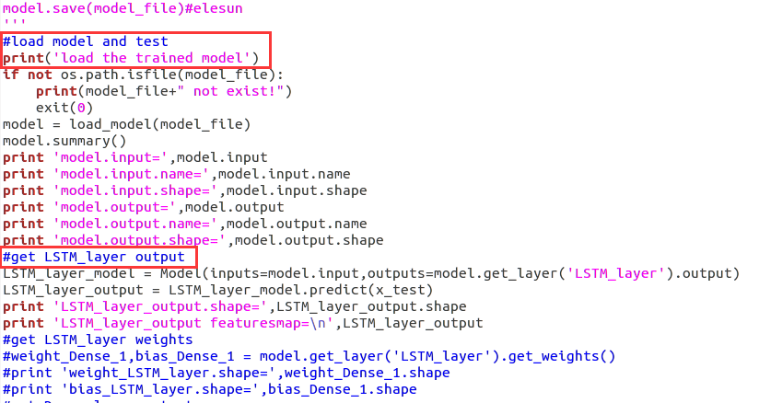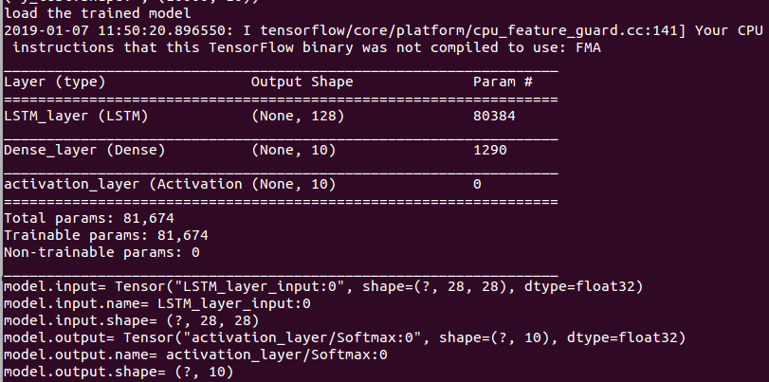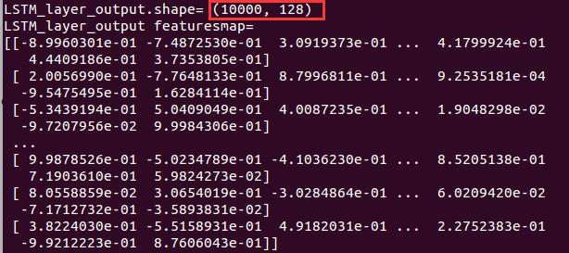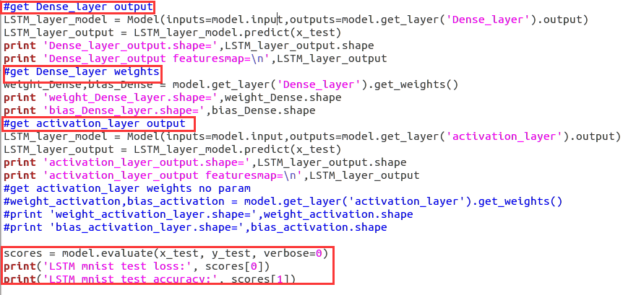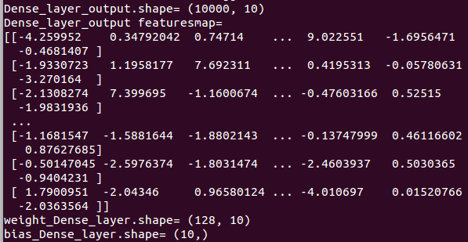
本层参数数量为128*10+10=1290，与网络输出表格一致。
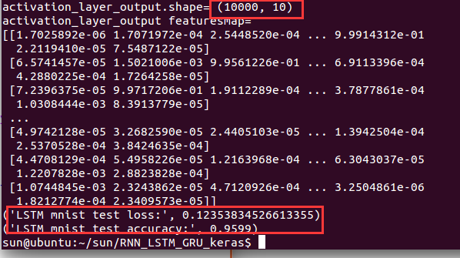

参考：
https://blog.csdn.net/change_great/article/details/73477514
https://keras.io/layers/recurrent/#lstm

